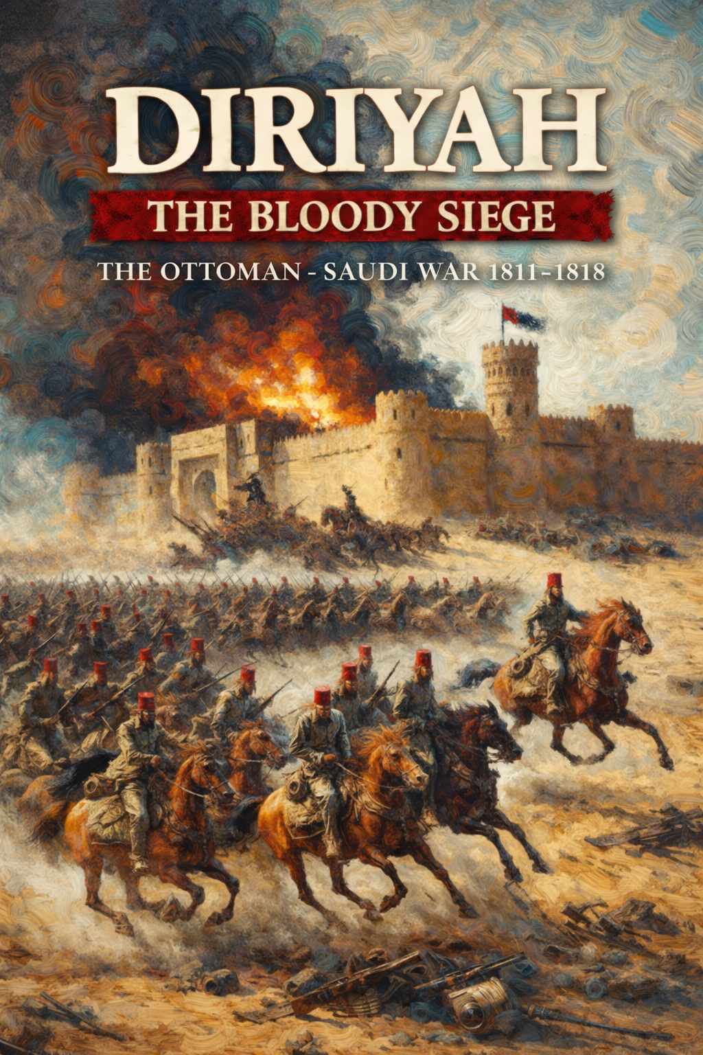
f
Rules of Play

TABLE OF CONTENTS

TABLE OF CONTENTS 2
INTRODUCTION 2
Parts Inventory 2
SETTING UP THE GAME 4
Counters 4

INTRODUCTION

Diriyah: The Bloody Siege is the second game in the ongoing States of Siege: Operational Series. It is a solitaire game telling the story of the Ottoman – Saudi war of 1811 – 1818 which culminated in the Siege of Diriyah, which was the capital of the First Saudi State.

The game comprises three separate campaigns, the outcome of one campaign feeding into start of the the next. The three campaigns are:

- The Hejaz Campaign, 1811 – 1815
- The Najd Campaign, 1816 – 1817
- The Siege of Diriyah, 1818

Each of these can be played as a separate standalone scenario, or the three can be combined into a Grand Campaign scenario.
For historical background of the conflict, the playbook
GAME EQUIPMENT

Parts Inventory
  - 3 24” x 10” maps
  - 150 game pieces
- Event Cards split into three decks (26 Hejaz, 19 Najd, and 20 Diriyah)
  - Various markers (Strength value modifiers for Supply, Morale)
  - 1 Rules booklet
  - 1 Playbook
  - 1 six-sided Die

The Game Maps

The following section shows the three game maps, one for each of the three campaigns.

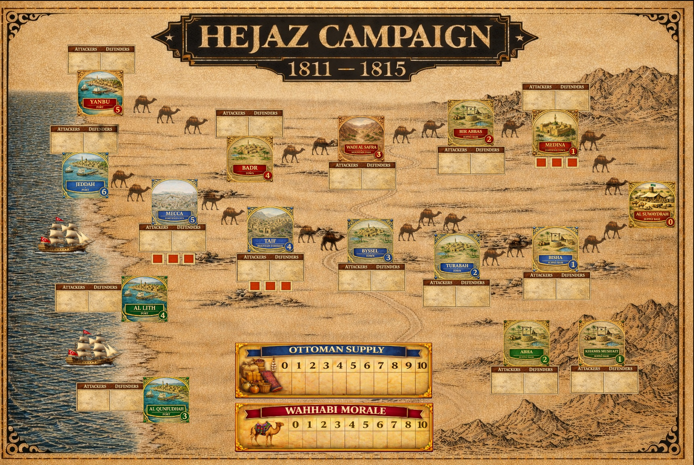

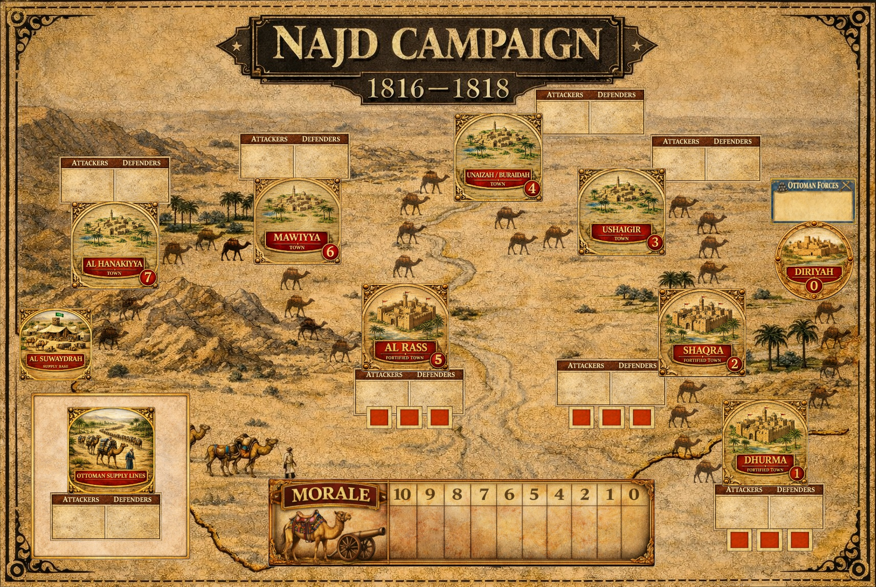

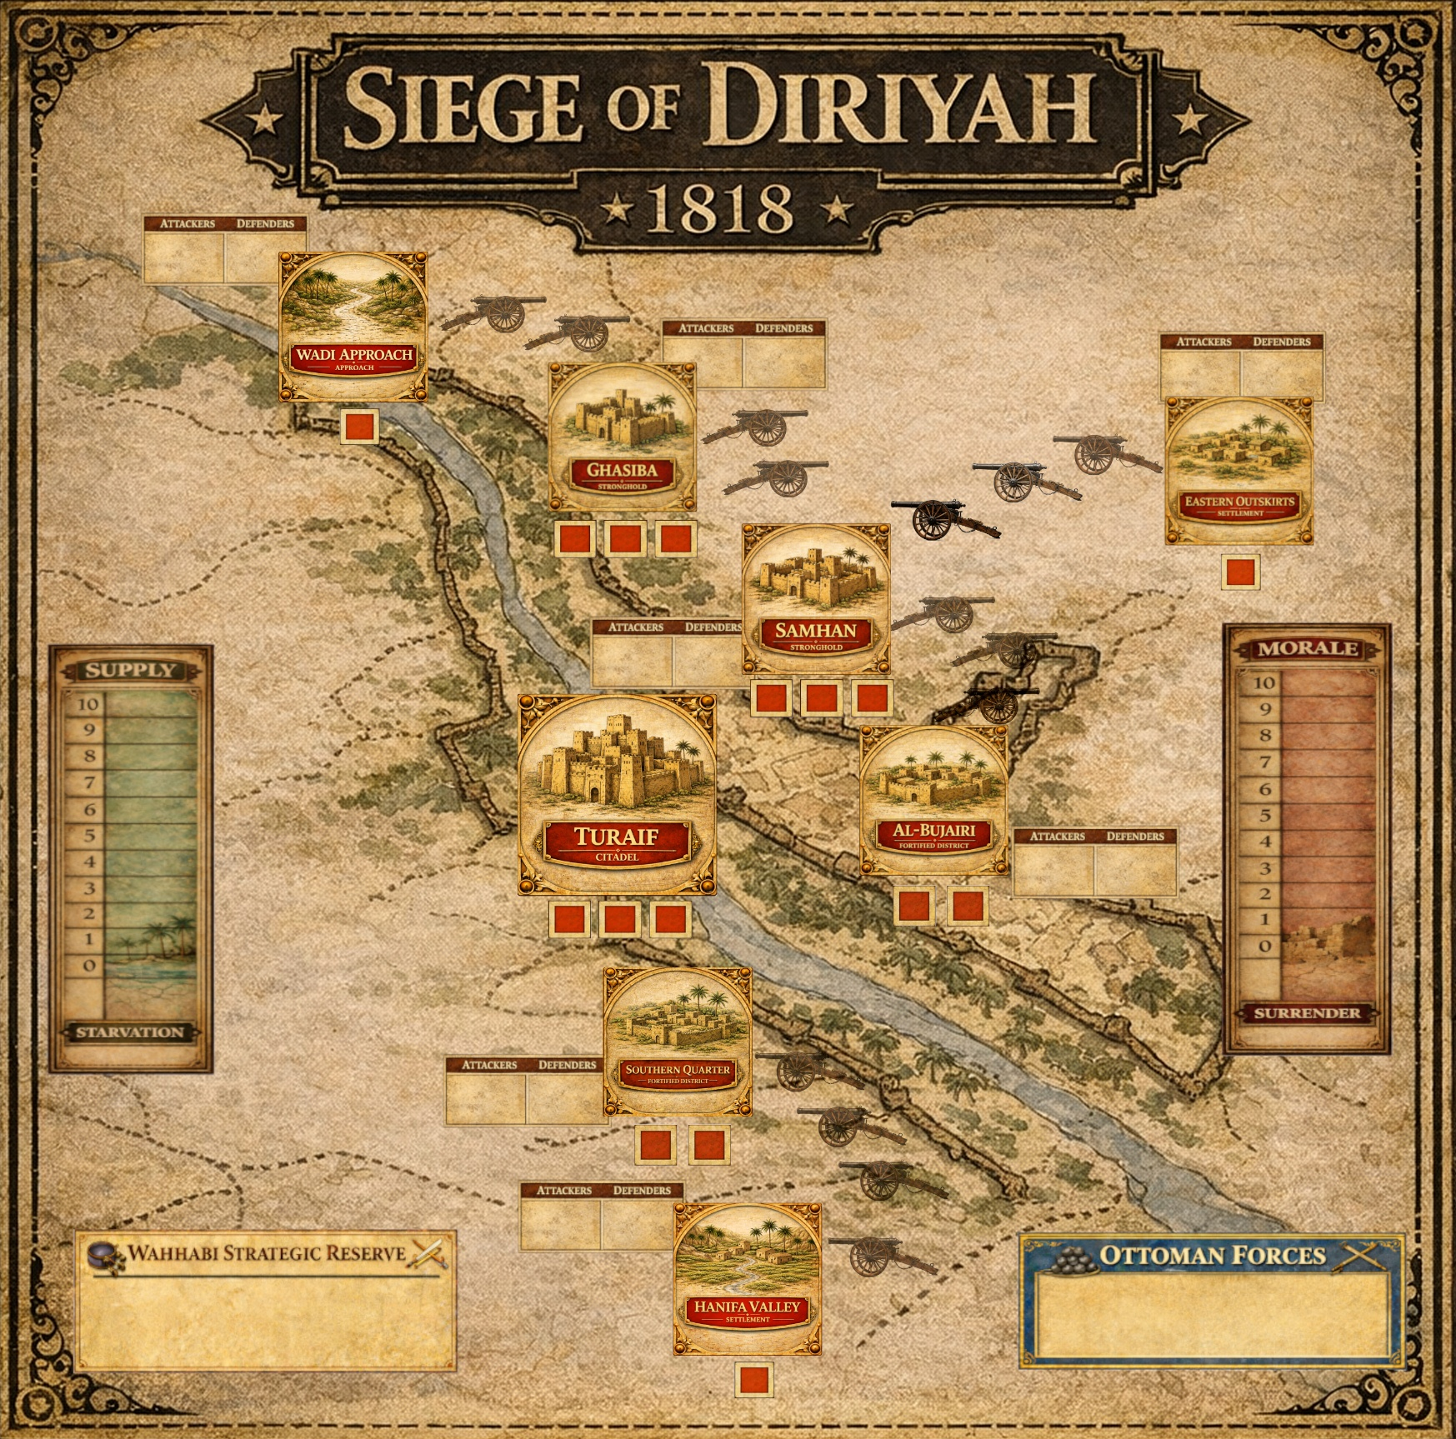

Text in shaded boxes, like this, provides the voice of the game’s designer, who is addressing you to explain an idea or concept that is not, itself, a Rule or a Case.

Event Cards

The three maps depict the regions and locations relevant to that part of the conflict. There are also various tracks =and boxes for morale, supply, troop force boxes, strategic reserves.

The type of each location is shown below its name; different types of locations imply different defensive benefits and/or different requireed modes of attack. In short, fortified locations require a siege to capture; non fortified locations can be attacked using conventional assauts, i.e., battle in the open.

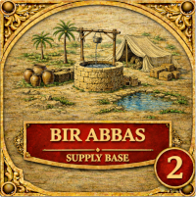
Location Name
Position on Track

Location Type

HEJAZ CAMPAIGN

SETTING UP THE GAME

There will be one section on each of the three campaigns, with instructtions on how to set up and play each game as a standalone game. Then, following those sections, there will be a further section on how to combine the three individual campaigns into a Grand Campaign.

Ottoman Counters
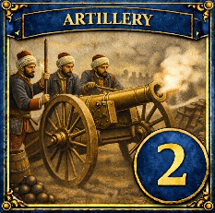
Artillery
Strength Points

